Guided LAB - 304.5.1 - Aggregate Functions

**Objective**

In this lab, you will demonstrate the aggregate function of SQL.

**Learning Objective:**

By the end of this lab, learners will be able to:

* Define the Aggregate Function.
* Use Aggregate Function in MySQL.

**Prerequisites:**

For this lab, you must have a “**classicmodesl”** database. If you do not have a ‘**classicmodels ‘** database setup, [**click here to download the database script file**.](https://drive.google.com/file/d/1JoT6N-kNhJ048ahXvvSgWNE0737NAdbb/view?usp=sharing)

**The database Schema** 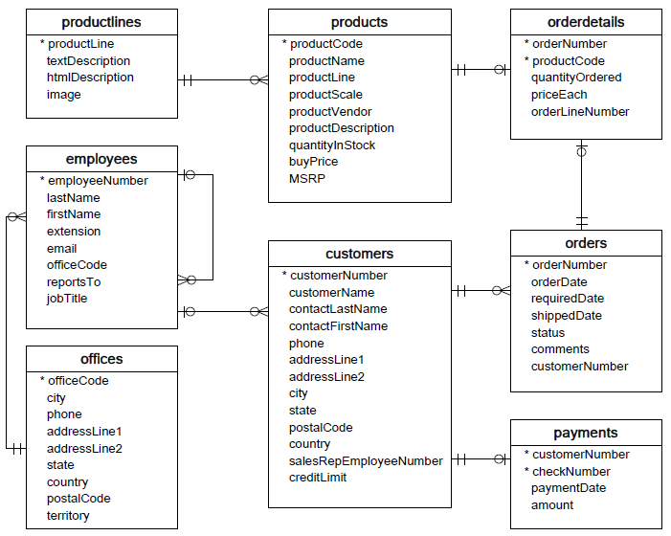

# Using MOD() function.

\We will use the orderDetails table from the sample database for the demonstration:

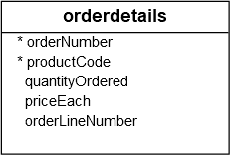

The following statement finds whether the quantity of products, which customers ordered, is odd or even.

| SELECT orderNumber, SUM(quantityOrdered) as Qty,      IF(MOD(SUM(quantityOrdered),2),'Odd', 'Even') as oddOrEven  FROM    orderdetails  GROUP BY    orderNumber  ORDER BY    orderNumber; |
| --- |

In this example:

* First, we used the SUM() function to get the total quantity of products by the sales order.
* Then we used the MOD() function to find the remainder of the total quantity divided by two. This results in zero or one, depending on where the total quantity is (even or odd).
* Finally, we used the [IF()](http://www.mysqltutorial.org/mysql-if-function.aspx) function to display the Odd and Even string based on the result of the MOD() function.

**Here is the output:**

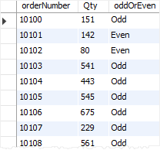

# TRUNCATE() Function

Let’s review some examples of using the TRUNCATE() function, using SQL TRUNCATE() with a positive number of decimal places.

SELECT TRUNCATE(1.555,1);

Here is the **output**:

MySQL TRUNCATE Function - positive number of decimal places

Because the number of decimal places argument is 1, the TRUNCATE() function keeps only one decimal place in the return value.

# ROUND() function

We will use the orderDetails table from the sample database for the demonstration.



The following query finds the average order line item values by product codes:

|  | SELECT productCode, AVG(quantityOrdered * priceEach) as avg_order_value  FROM orderDetails  GROUP BY productCode; |
| --- | --- |

Here is the output:

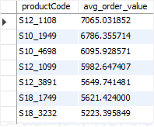

The average order values of products are not quite readable because they contain many numbers after the decimal points.

For the average values, the number after the decimal point may not be important. Therefore, you can use the ROUND() function to round them to zero decimal places, as shown in the following query:

|  | SELECT     productCode,    ROUND(AVG(quantityOrdered * priceEach)) as avg_order_item_value  FROM     orderDetails  GROUP BY    productCode; |
| --- | --- |

The following picture shows the output:

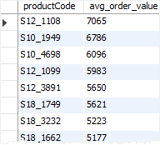

SQL TRUNCATE() vs. ROUND()

The following example uses both TRUNCATE() and ROUND() function for comparison:

| SELECT   TRUNCATE(1.999,1),  ROUND(1.999,1); |
| --- |

Here is the query output:

MySQL TRUNCATE Function Example

As clearly shown in the output, the TRUNCATE() function only trims the decimal places while the ROUND() function performs the rounding.

# REPLACE() Function

The **syntax** of using the REPLACE() function in an UPDATE statement is as follows:

|  | UPDATE tbl_name SET      field_name = REPLACE(field_name, string_to_find, string_to_replace)  WHERE    conditions; |
| --- | --- |

Note that when searching for text to replace, SQL uses the case-sensitive match to perform a search for a string to be replaced.

For example, if you want to correct the spelling mistake in the products table in the sample database, you can use the REPLACE() function as follows:

|  | UPDATE products  SET productDescription = REPLACE(productDescription,'abuot','about'); |
| --- | --- |

The above query will find all occurrences of a spelling mistake ’abuot,’ and replaces it by the correct word ‘*about’* in the productDescription column of the products table.

# DATEDIFF() function

1. Let’s take a look at some examples of using the DATEDIFF()  function.

SELECT DATEDIFF('2011-08-17','2011-08-17');

#Result :   0 day

SELECT DATEDIFF('2011-08-17','2011-08-08');

#Result:  9 days

SELECT DATEDIFF('2011-08-08','2011-08-17');

#Result: -9 days

1. See the following orders table in the sample database.

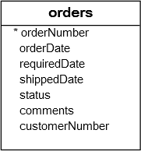

a) To calculate the number of days between the required date and shipped date of the orders, we can use the DATEDIFF() function as follows:

|  | SELECT orderNumber, DATEDIFF(requiredDate, shippedDate) as daysLeft  FROM     orders  ORDER BY daysLeft DESC; |
| --- | --- |

**Result:**

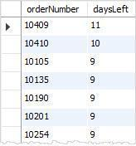

b) The following statement gets all orders whose status is “In Process,” and calculates the number of days between the ordered date and the required date:

| SELECT orderNumber, DATEDIFF(requiredDate, orderDate) as remaining_days  FROM    orders  WHERE    status = 'In Process'  ORDER BY remaining_days; |
| --- |

[**Try It Out**](http://www.mysqltutorial.org/tryit/query/mysql-datediff/#5)

**Result:**

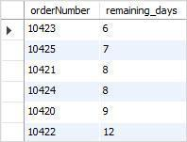

c) For calculating an interval in week or month, you can divide the returned value of the DATEDIFF() function by 7 or 30 as the following query:

|  | SELECT      orderNumber,      ROUND(DATEDIFF(requiredDate, orderDate) / 7, 2),      ROUND(DATEDIFF(requiredDate, orderDate) / 30,2)  FROM     orders  WHERE    status = 'In Process'; |
| --- | --- |

[**Try It Out**](http://www.mysqltutorial.org/tryit/query/mysql-datediff/#6)

**Result**

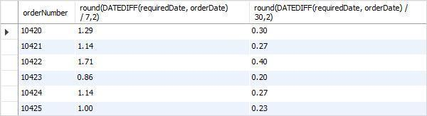

Note that the ROUND() function is used to round the results.

# 

# **DATE_FORMAT()** F**unction**

| **Specifier** | **Meaning** |
| --- | --- |
| %a | Three-characters abbreviated weekday names e.g., Mon, Tue, Wed, etc. |
| %b | Three-characters abbreviated month name e.g., Jan, Feb, Mar, etc. |
| %c | Month in numeric e.g., 1, 2, 3…12 |
| %D | Day of the month with English suffix e.g., 0th, 1st, 2nd, etc. |
| %d | Day of the month with leading zero if it is 1 number e.g., 00, 01,02, …31 |
| %e | Day of the month without leading zero e.g., 1,2,…31 |
| %f | Microseconds in the range of 000000..999999 |
| %H | Hour in 24-hour format with leading zero e.g., 00..23 |
| %h | Hour in 12-hour format with leading zero e.g., 01, 02…12 |
| %I | Same as %h |
| %i | Minutes with leading zero e.g., 00, 01,…59 |
| %j | Day of year with leading zero e.g., 001,002,…366 |
| %k | Hour in 24-hour format without leading zero e.g., 0,1,2…23 |
| %l | Hour in 12-hour format without leading zero e.g., 1,2…12 |
| %M | Full month name e.g., January, February,…December |
| %m | Month name with leading zero e.g., 00,01,02,…12 |
| %p | AM or PM, depending on other time specifiers |
| %r | Time in 12-hour format hh:mm:ss AM or PM |
| %S | Seconds with leading zero 00,01,…59 |
| %s | Same as %S |
| %T | Time in 24-hour format hh:mm:ss |
| %U | Week number with leading zero when the first day of week is Sunday e.g., 00,01,02…53 |
| %u | Week number with leading zero when the first day of week is Monday e.g., 00,01,02…53 |
| %V | Same as %U; it is used with %X |
| %v | Same as %u; it is used with %x |
| %W | Full name of weekday e.g., Sunday, Monday,…, Saturday |
| %w | Weekday in number (0=Sunday, 1= Monday,etc.) |
| %X | Year for the week in four digits where the first day of the week is Sunday; often used with %V |
| %x | Year for the week, where the first day of the week is Monday, four digits; used with %v |
| %Y | Four digits year e.g., 2000 and 2001. |
| %y | Two digits year e.g., 10,11,and 12. |
| %% | Add percentage (%) character to the output |

The following are some commonly used date format strings:

| **DATE_FORMAT string** | **Formatted date** |
| --- | --- |
| %Y-%m-%d | 7/4/2013 |
| %e/%c/%Y | 4/7/2013 |
| %c/%e/%Y | 7/4/2013 |
| %d/%m/%Y | 4/7/2013 |
| %m/%d/%Y | 7/4/2013 |
| %e/%c/%Y %H:%i | 4/7/2013 11:20 |
| %c/%e/%Y %H:%i | 7/4/2013 11:20 |
| %d/%m/%Y %H:%i | 4/7/2013 11:20 |
| %m/%d/%Y %H:%i | 7/4/2013 11:20 |
| %e/%c/%Y %T | 4/7/2013 11:20 |
| %c/%e/%Y %T | 7/4/2013 11:20 |
| %d/%m/%Y %T | 4/7/2013 11:20 |
| %m/%d/%Y %T | 7/4/2013 11:20 |
| %a %D %b %Y | Thu 4th Jul 2013 |
| %a %D %b %Y %H:%i | Thu 4th Jul 2013 11:20 |
| %a %D %b %Y %T | Thu 4th Jul 2013 11:20:05 |
| %a %b %e %Y | Thu Jul 4 2013 |
| %a %b %e %Y %H:%i | Thu Jul 4 2013 11:20 |
| %W %D %M %Y | Thursday 4th July 2013 |
| %W %D %M %Y %H:%i | Thursday 4th July 2013 11:20 |
| %W %D %M %Y %T | Thursday 4th July 2013 11:20:05 |
| %l:%i %p %b %e, %Y | 7/4/2013 11:20 |
| %M %e, %Y | 4-Jul-13 |
| %a, %d %b %Y %T | Thu, 04 Jul 2013 11:20:05 |

Let’s take a look at the orders table in the sample database.



To select the order’s data and format the date value, you can use the query statement:

|  | SELECT      orderNumber,      DATE_FORMAT(orderdate, '%Y-%m-%d') orderDate,      DATE_FORMAT(requireddate, '%a %D %b %Y') requireddate,      DATE_FORMAT(shippedDate, '%W %D %M %Y') shippedDate  FROM    orders; |
| --- | --- |

**Result:**

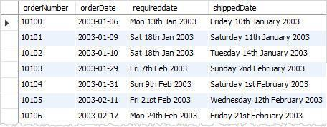

We formatted the order date, required date, and shipped date of each order based on different date formats specified by the format strings.

Let’s use DATE_FORMAT() with the ORDER BY clause and review the following example:

|  | SELECT     orderNumber,      DATE_FORMAT(shippeddate, '%W %D %M %Y') as 'Shipped date'  FROM    orders  ORDER BY shippeddate; |
| --- | --- |

**Result:**

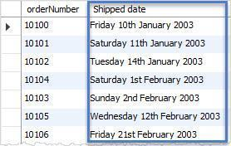

# LPAD(*str*, *len*, *padstr*)

* The LPAD() function left-pads a string with another string to a certain length.
* LPAD() function returns the string ***str***, left-padded with the string ***padstr*** to a length of ***len*** characters. If ***str*** is longer than ***len***, the return value is shortened to ***len*** characters.

[Click here for more details.](https://dev.mysql.com/doc/refman/8.0/en/string-functions.html#function_lpad)

**Example:**

SELECT LPAD('hi',4,'??');  *#Result -> '??hi'*

SELECT LPAD('hi',1,'??');  *# Result -> 'h'*

Let’s take a look at the employees table in the ’classicmodels’ database.

SELECT firstName, LPAD(firstName,10,'kk'), LPAD(firstName,5,'kk'), LPAD(firstName,4,'kk') FROM classicmodels.employees;

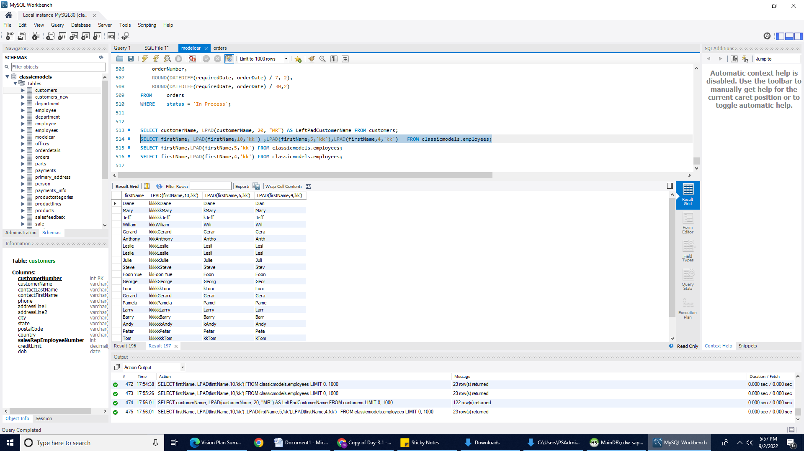

# 7. SQL TRIM() Function

The data from the user's input is typically not what we expected. Sometimes, it is not well-formed (e.g., wrong cases; those containing leading and trailing spaces and other unwanted characters).

To keep the data in the correct format, before inserting or updating data in the database, you need to clean it up. One of the most important tasks in data cleansing is to remove unwanted leading and trailing characters.

SQL provides a very useful string function named TRIM to help you clean up the data. The following illustrates the syntax of the TRIM function.

| 1 | TRIM([{BOTH|LEADING|TRAILING} [removed_str]] FROM str); |
| --- | --- |

The TRIM function provides several options

* You can use the LEADING, TRAILING, or BOTH option to explicitly instruct the TRIM function to remove leading, trailing, or both leading and trailing unwanted characters from a string.
* If you do not specify anything, the TRIM function uses the BOTH options by default.
* The [removed_str] is the string that you want to remove. By default, it is a space. It means that if you do not specify a particular string, the TRIM function removes spaces only.
* The TRIM function returns a string that has unwanted characters removed.
* The following statement removes both leading and trailing spaces from a string.

|  | **SELECT TRIM(' SQL TRIM Function ');** |
| --- | --- |

We will take the products table in the sample database for the demonstration.

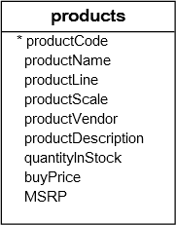

## SQL LTRIM and RTRIM function

If you want to remove only leading or trailing spaces, you can use other string functions such as LTRIM and RTRIM.

The following statement uses the LTRIM function to remove the leading spaces of a string.

|  | **SELECT LTRIM('  SQL LTRIM function');** |
| --- | --- |

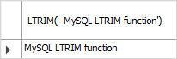

The following statement uses the RTRIM function to remove the trailing spaces of a string.

|  | SELECT RTRIM('SQL RTRIM function   '); |
| --- | --- |

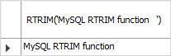

# YEAR() Function

* The YEAR() function takes a date argument and returns the year of the date.
* The YEAR() function returns a year value in the range 1000 to 9999. If the date is zero, the YEAR() function returns 0.
* The following example returns the year January 1st, 2022, which is 2022.

| SELECT YEAR('2002-01-01'); |
| --- |

* Let’s consider the orders table in the **classicmodels** database.



The following query uses the **YEAR()** function to get the number of orders shipped per year.

| SELECT YEAR(shippeddate) as year, COUNT(ordernumber) as orderQty  FROM orders  GROUP BY YEAR(shippeddate)  ORDER BY YEAR(shippeddate); |
| --- |

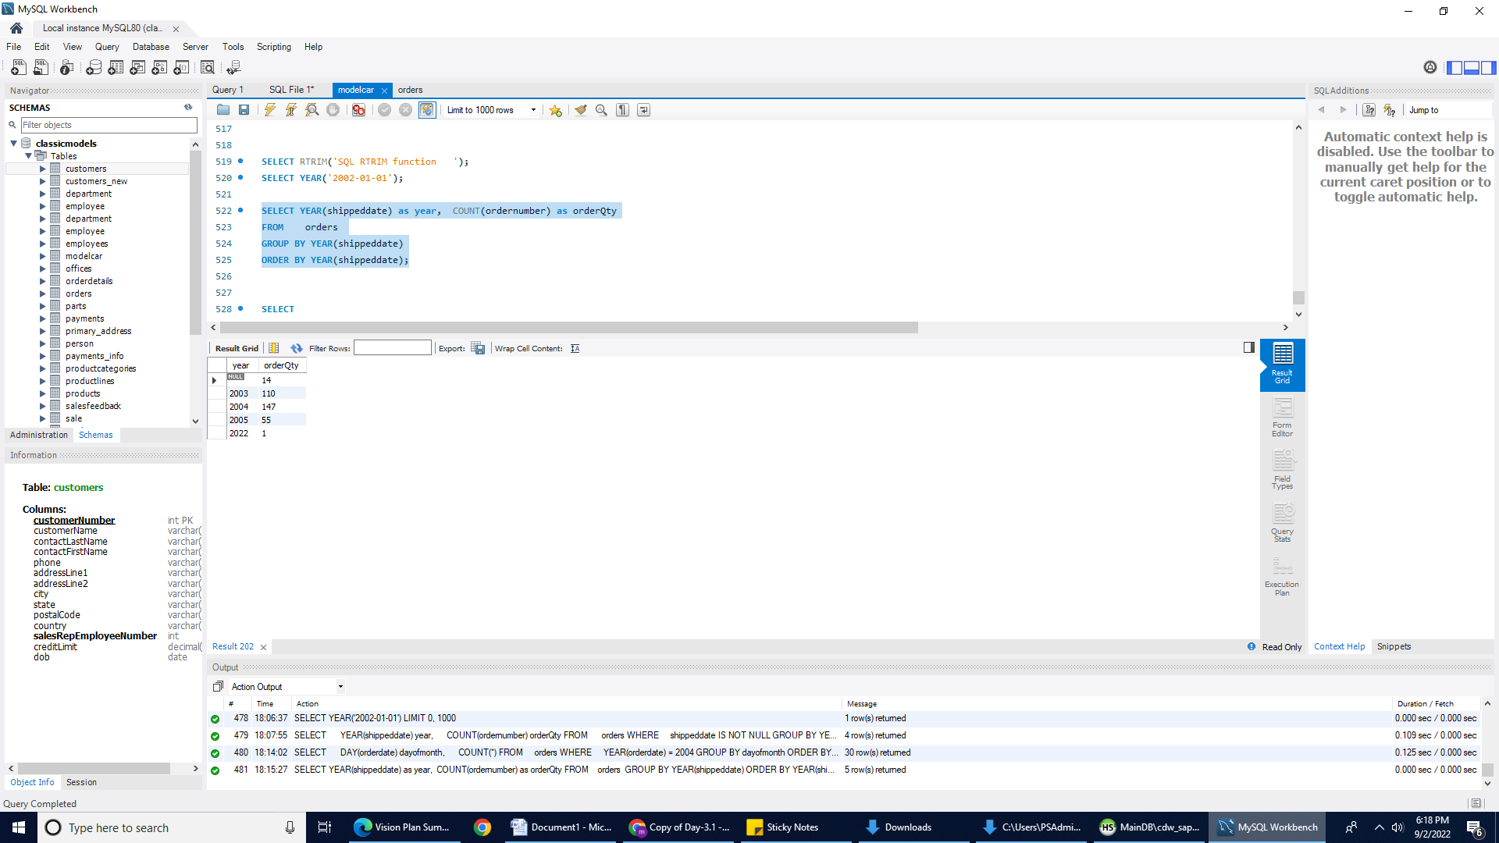

In this example, we use the YEAR() function to extract year information out of the shipped date and use the COUNT() function to count the number of delivered orders. The GROUP BY clause groups the number of orders by year.

# DAY() Function

* The DAY() function returns the day of the month of a given date.
* The DAY() function accepts one argument, which is a date value for which you want to get the day of the month. If the date argument is zero e.g., '0000-00-00', the DAY() function returns 0. If the date is [NULL](https://www.mysqltutorial.org/mysql-null/), the DAY() function returns NULL.
* Note that the DAY() function is the synonym of the DAYOFMONTH() function.

The following example returns the day of the month of 2022-01-15:

| SELECT DAY('2022-01-15'); |
| --- |

Consider the following orders table.



The following statement uses the DAY() function to return the number of orders by day number in 2004.

| SELECT DAY(orderdate) as dayofmonth, COUNT(*)  FROM orders WHERE YEAR(orderdate) = 2004  GROUP BY dayofmonth  ORDER BY dayofmonth; |
| --- |

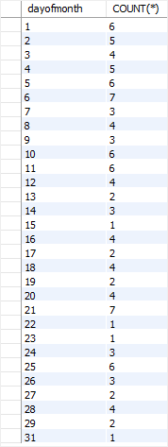

**Submission Instructions:**

**Canvas submission Instructions:** Include the following deliverables in your submission -

* + All queries should be written and submitted in a single SQL script file.
    - Example :**<your_name_labname>.sql**.
  + **Do not add the questions in your SQL script file.**
  + Submit your SQL script file using the **Start** **Assignment** button in the top-right corner of the assignment page in Canvas.

## 